**AMERICAN INTERNATIONAL UNIVERSITY–BANGLADESH (AIUB)**

**FACULTY OF SCIENCE & TECHNOLOGY**

**DEPARTMENT OF COMPUTER SCIENCE**

**COMPUTER GRAPHICS**

**Spring 2023-2024**

**Section: D, Group: 05**

**Project Title: Futuristic City View & Smart Fire Management System**

Supervise By

**ANEEM AL AHSAN RUPAI**

**Group Member:**

|  |  |
| --- | --- |
| **Name** | **ID** |
| Farjana Yesmin Opi | 22-47018-1 |
| Md. Abu Towsif | 22-47019-1 |
| A.F.M. Rafiul Hassan | 22-47048-1 |

**Table of Contents**

**Topic**  **Page No.**

Introduction ­ - - - - - - - - - - - - - - - - - - - - - - - - - - - - - - - - - - - - - - - - 3

Project Graph ­ - - - - - - - - - - - - - - - - - - - - - - - - - - - - - - - - - - - - - - - 4

List of Objects­ - - - - - - - - - - - - - - - - - - - - - - - - - - - - - - - - - - - - - - - 5-7

List of Functions ­ - - - - - - - - - - - - - - - - - - - - - - - - - - - - - - - - - - - - - - 8-10

List of Animation Functions ­ - - - - - - - - - - - - - - - - - - - - - - - - - - - - - - - 11

Conclusion ­ - - - - - - - - - - - - - - - - - - - - - - - - - - - - - - - - - - - - - - - - - - 12

Output Screenshots - - - - - - - - - - - - - - - - - - - - - - - - - - - - - - - - - - - - - 13-15

**Introduction**

The title of our project is ‘Futuristic City View & Smart Fire Management System’. In this project we tried to implement the view of how a futuristic city will be look like and how will be the fire management system in future. There are three scenarios in the project. The first scenario is of a city where we have the next version of all the components of a city like futuristic bullet trains, cars, and buildings. There is underground train station. Also there are futuristic cars and smart cars as well. Animated ballons moving in the sky is also designed. Robots will be used very often in the future. So , there are some robots in the first scenario in the underground train station. We added animations to these objects in order to look more realistic. Then we will have the second scenario. In the second scenario, we designed a futuristic Fire Station. We replicated the view of the next version fire station. There are be vehicles such as fire trucks and helicopters in the fire station. Again there is animation in the scenario. Then we will have our third scenario. The third scenario is also a scenario of a modern futuristic city. However, the design and components of the third scenario is completely different from the first scenario. In the third scenario there are smart cars, modern bullet train, and modern buildings. There are also futuristic flying car. Moving animation is also added to all of the objects. Flower with leaf’s moving is also designed in this scenario. This looks so realistic. The main part of this scenario is that one of the buildings will get fire. To extinguish the fire, A helicopter will come from the fire station and will begin to extinguish the fire with rain effect. So, in this scenario, fire effect, automatic helicopter movement, rain effect is used. The main objective of our project is to replicate a futuristic city view and to show the view of how the fire management system will look in the near future.

**Technologies used**

We used opengl to create the entire project. We used different features of Opengl like lines, polygon, circle drawing, moving animations, rotation animation. We used Geogebra online graphing tool to graph the entire project. We took help from some of the online websites like freepik, Shutterstock to search for vectors and designs. BMP pictures and textures are also used in the project.

**Project Graph**

Third Scenario

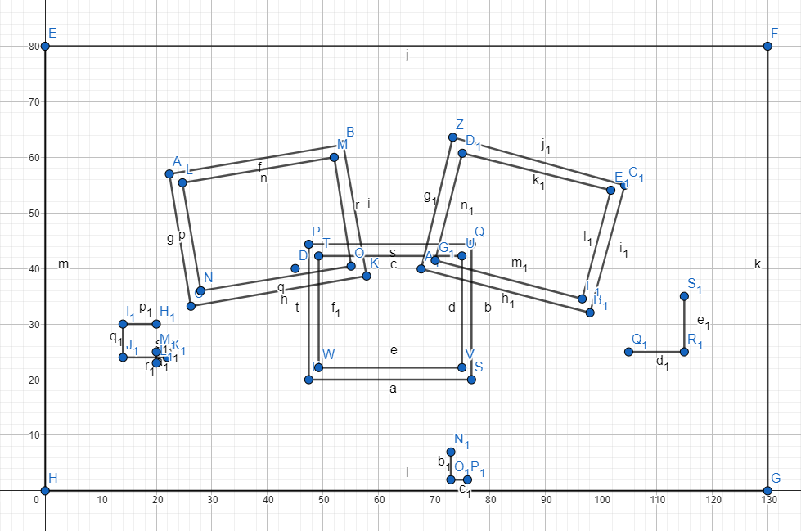Intro page:

**List of Objects**

|  |  |  |
| --- | --- | --- |
| **SL#** | **Object ID** | **Object Name** |
| 1 | ID – 01 | left_pond |
| 2 | ID – 02 | front_road |
| 3 | ID – 03 | side_green_area |
| 4 | ID – 04 | poll_first |
| 5 | ID – 05 | poll_second |
| 6 | ID – 06 | road |
| 7 | ID – 07 | drawRain |
| 8 | ID – 08 | ciecle |
| 9 | ID – 09 | train_platform |
| 10 | ID – 10 | train_piller01 |
| 11 | ID – 11 | train_piller02 |
| 12 | ID – 12 | train_piller03 |
| 13 | ID – 13 | train_piller04 |
| 14 | ID – 14 | train01 |
| 15 | ID – 15 | train02 |
| 16 | ID – 16 | train03 |
| 17 | ID – 17 | building _01 |
| 17 | ID – 18 | building _02 |
| 19 | ID – 19 | building _03 |
| 20 | ID – 20 | building _04 |
| 21 | ID – 21 | building _05 |
| 22 | ID – 22 | building _06 |
| 23 | ID – 23 | building _07 |
| 24 | ID – 24 | building _08 |
| 25 | ID – 25 | building _09 |
| 26 | ID – 26 | building _10 |
| 27 | ID – 27 | building _11 |
| 28 | ID – 28 | sky |
| 29 | ID – 29 | flying_car_01 |
| 30 | ID – 30 | flying_car_02 |
| 31 | ID – 31 | flying_car_03 |
| 32 | ID – 32 | flying_car_04 |
| 33 | ID – 33 | bird01 |
| 34 | ID – 34 | bird02 |
| 35 | ID – 35 | bird03 |
| 36 | ID – 36 | bird04 |
| 37 | ID – 37 | bird05 |
| 38 | ID – 38 | tree_01 |
| 39 | ID – 39 | tree_02 |
| 40 | ID – 40 | tree_03 |
| 41 | ID – 41 | tree_04 |
| 42 | ID – 42 | tree_05 |
| 43 | ID – 43 | tree_06 |
| 44 | ID – 44 | tree_07 |
| 45 | ID – 45 | tree_08 |
| 46 | ID – 46 | tree_09 |
| 47 | ID – 47 | trees_back_tree01 |
| 48 | ID – 48 | upper_road_area |
| 49 | ID – 49 | cybertruck_01 |
| 50 | ID – 50 | eco_car02 |
| 51 | ID – 51 | auto_motorcycle03 |
| 52 | ID – 52 | eco_car04 |
| 52 | ID – 53 | left_pond_upper |
| 54 | ID – 54 | flower_right_grass |
| 55 | ID – 55 | helicopter |
| 56 | ID – 56 | fire_show |
| 57 | ID – 57 | fire |
| 58 | ID – 58 | smoke_fire_all |
| 59 | ID – 59 | fire_smoke |
| 60 | ID – 75 | Opipic |
| 61 | ID – 76 | Rafipic |
| 62 | ID – 77 | Tishatpic |
| 63 | ID – 78 | Back_texture |

List of Functions:

|  |  |  |
| --- | --- | --- |
| **SL#** | **Object Name** | **FunctionName** |
| 1 | left_pond | left_pond() |
| 2 | front_road | front_road() |
| 3 | side_green_area | side_green_area() |
| 4 | poll_first | poll_first() |
| 5 | poll_second | poll_second() |
| 6 | road | road() |
| 7 | drawRain | drawRain() |
| 8 | ciecle | ciecle() |
| 9 | train_platform | train_platform() |
| 10 | train_piller01 | train_piller01() |
| 11 | train_piller02 | train_piller02() |
| 12 | train_piller03 | train_piller03() |
| 13 | train_piller04 | train_piller04() |
| 14 | train01 | train01() |
| 15 | train02 | train02() |
| 16 | train03 | train03() |
| 17 | building _01 | building _01() |
| 17 | building _02 | building _02() |
| 19 | building _03 | building _03() |
| 20 | building _04 | building _04() |
| 21 | building _05 | building _05() |
| 22 | building _06 | building _06() |
| 23 | building _07 | building _07() |
| 24 | building _08 | building _08() |
| 25 | building _09 | building _09() |
| 26 | building _10 | building _10() |
| 27 | building _11 | building _11() |
| 28 | sky | sky() |
| 29 | flying_car_01 | flying_car_01() |
| 30 | flying_car_02 | flying_car_02() |
| 31 | flying_car_03 | flying_car_03() |
| 32 | flying_car_04 | flying_car_04() |
| 33 | bird01 | bird01() |
| 34 | bird02 | bird02() |
| 35 | bird03 | bird03() |
| 36 | bird04 | bird04() |
| 37 | bird05 | bird05() |
| 38 | tree_01 | tree_01() |
| 39 | tree_02 | tree_02() |
| 40 | tree_03 | tree_03() |
| 41 | tree_04 | tree_04() |
| 42 | tree_05 | tree_05() |
| 43 | tree_06 | tree_06() |
| 44 | tree_07 | tree_07() |
| 45 | tree_08 | tree_08() |
| 46 | tree_09 | tree_09() |
| 47 | trees_back_tree01 | trees_back_tree01() |
| 48 | upper_road_area | upper_road_area() |
| 49 | cybertruck_01 | cybertruck_01() |
| 50 | eco_car02 | eco_car02() |
| 51 | auto_motorcycle03 | auto_motorcycle03() |
| 52 | eco_car04 | eco_car04() |
| 52 | left_pond_upper | left_pond_upper() |
| 54 | flower_right_grass | flower_right_grass() |
| 55 | helicopter | helicopter() |
| 56 | fire_show | fire_show() |
| 57 | fire | fire() |
| 58 | smoke_fire_all | smoke_fire_all() |
| 59 | fire_smoke | fire_smoke() |
| 60 | fire_smoke() | Opipic() |
| 61 | Opipic | Rafipic() |
| 62 | Rafipic | Tishatpic() |
| 63 | Tishatpic | Back_texture() |

List of Animation Functions

|  |  |  |  |
| --- | --- | --- | --- |
| **SL#** | **Animation Function ID** | **Animation Function** | **Object/Scene** |
| 1 | ID - 61 | Change_wing | Birds wing change |
| 2 | ID – 62 | fly | Birds flying |
| 3 | ID – 63 | _move_train | Train movement |
| 4 | ID – 64 | wave_fire | Fire particle parts moving |
| 5 | ID – 65 | zoom_fire | Fire particle zooming |
| 6 | ID - 66 | fire_animatoin | fire particle appearing and vanishing |
| 7 | ID – 67 | rotate_fan1 | helicopter, flying cars |
| 8 | ID – 68 | move_helicopter | Helicopter moving |
| 9 | ID – 69 | update | Rain /water effect |
| 10 | ID - 70 | move_flying_car | Flying cars |
| 11 | ID - 71 | move_fire_smoke | Smoke of fire moving |
| 12 | ID - 72 | move_jungle_leaf | Flowers and leaf move  animaton |
| 13 | ID - 73 | move_cars | Cars moving |
| 14 | ID - 74 | zoom_to_fire_animation | zoom to fire and building 11 |
| 15 | ID - 75 | kepress_handle | Keyboard press interaction |
| 16 | ID – 79 | zoom_to_normal_view | zoom to normal view  of intro page |
| 17 | ID - 80 | keyborard_func | Keyboard press interaction  of intro page |

**Conclusion**

In conclusion, our project "Futuristic City View & Smart Fire Management System" successfully illustrates a visionary outlook on urban development and emergency response systems. The first scenario provides a glimpse into the daily life of a futuristic city, highlighting innovations such as bullet trains, smart cars, and the widespread use of robots. The second scenario showcases the evolution of fire stations, equipped with state-of-the-art vehicles and preparedness to tackle emergencies efficiently. Scenario three provides a vivid representation of a modern futuristic city, emphasizing advanced technologies and their integration into urban life. The highlight of scenario three is the smart fire management system, which showcases the efficiency and responsiveness of future emergency services. The dynamic interaction between fire particles and the automated helicopter illustrates a sophisticated and adaptive approach to firefighting. The helicopter's rain effect to extinguish the fire not only demonstrates advanced technology but also emphasizes the importance of quick and effective emergency response in future cities. Utilizing OpenGL for creating animations and designs, along with tools like Geogebra for graphing, we have ensured a high level of detail and interactivity in our project. The use of BMP pictures and textures along with wav files for sound effect has further enhanced the visual appeal and realism of third scenario in fact the whole project.

Overall, this project not only serves as a conceptual model for futuristic city planning and fire management but also highlights the potential of current technology to shape the cities of tomorrow. We hope this project inspires further exploration and development in urban innovation and emergency response systems.

**Output Screenshots**

Picture – 01 : Initial view of third scenario

Picture – 02 : Fire and fire smoke effect of third scenario

Picture – 03 : Helicopter and water effect to distinguish the fire

Picture – 04 : Zoom effect on helicopter and fire

Picture – 05 :Last view of third scenario of destroyed texture applied on building after fire